Deliverables Task:

1-Share GitHub public repository URL for your code base.

<https://github.com/nishitamaheshwari-nagarro/Docker-K8Assignment-Tasks/tree/main/spring-boot-docker>

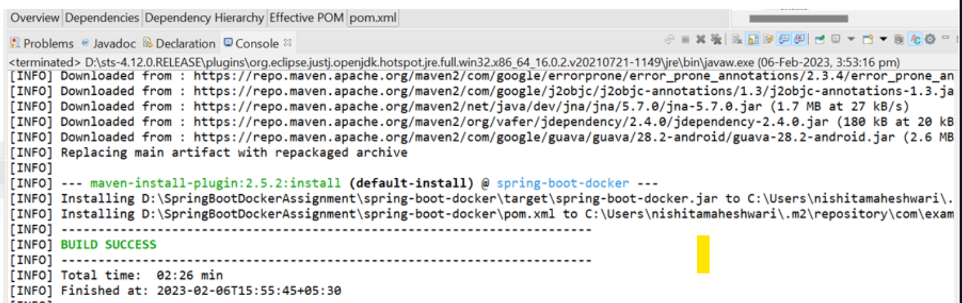

2. Share Docker File

<https://github.com/nishitamaheshwari-nagarro/Docker-K8Assignment-Tasks/blob/main/Dockerfile>

3. 3. Screenshot of Docker Image Created Successfully & Total Number of Docker images.

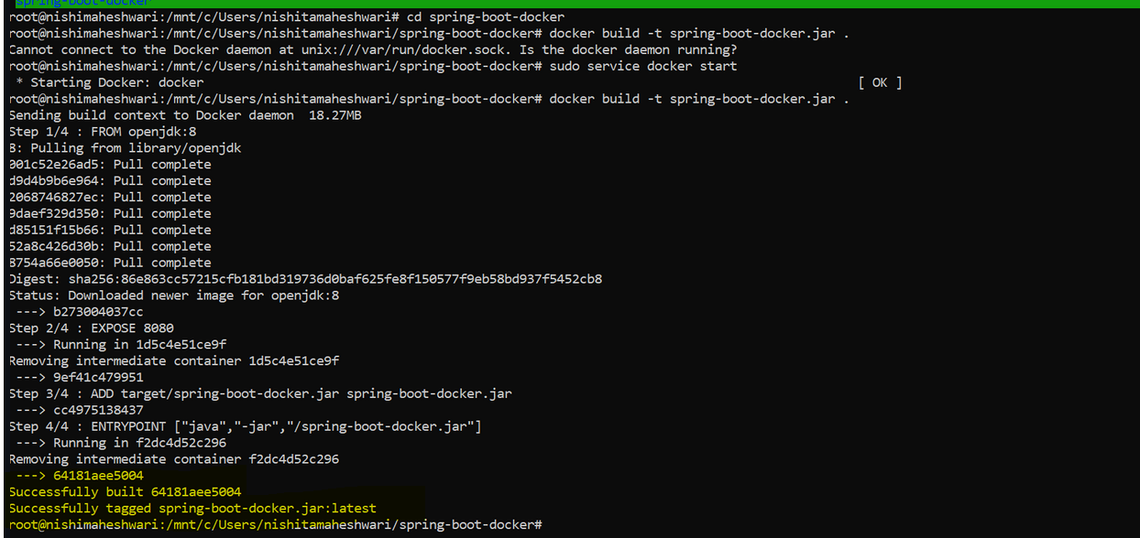  
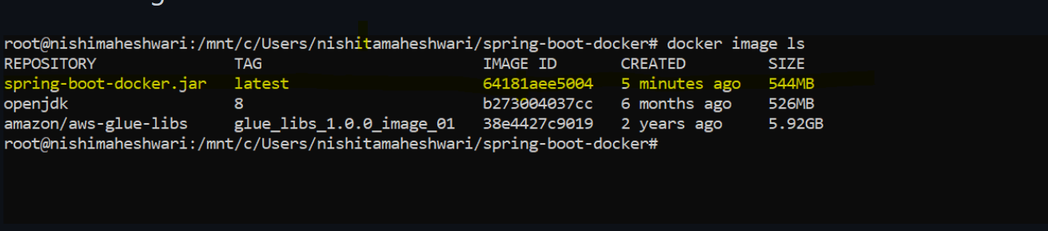

4. Share the Image path from Docker Hub Repo

<https://hub.docker.com/u/nishitamaheshwari>

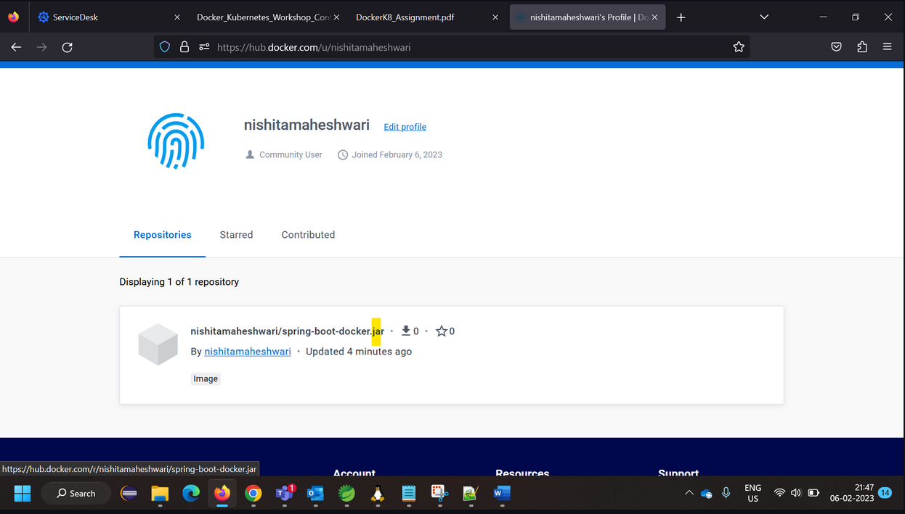

5. Share Both the Yamls Files (Deployment & Service).

<https://github.com/nishitamaheshwari-nagarro/Docker-K8Assignment-Tasks/blob/main/k8s-deployment.yaml>

<https://github.com/nishitamaheshwari-nagarro/Docker-K8Assignment-Tasks/blob/main/k8s-service.yaml>

6. Two Screenshots: One for Deployment Created Successfully and Second for Total Number of Deployments





7. Two Screenshots: One for Screenshot of Service Created Successfully and Second for Total Number of Running services.



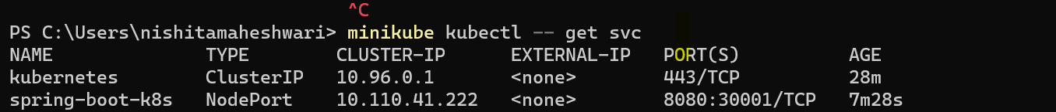

8. Screenshot for Number of Running Pods.



9. Screenshot of Running Application. (Show Endpoint is accessible successfully through browser)

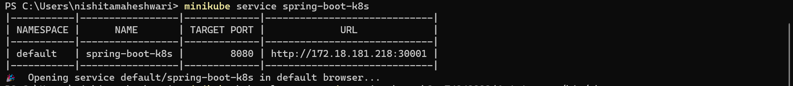

10. Screenshot - Access pod through the service endpoint only.

